
Sutro Biopharma announced the de-prioritization of development of Luvelta (luveltamab tazeibulin; FRα hemiasterlin ADC) as part of a strategic restructuring to extend Sutro’s cash runway through 2026 and focus on development of three pre-IND ADC candidates. (presentation | press release | webcast). At a minimum, this news will likely result in significant development delays to Luvelta, which has struggled to demonstrate a clinically differentiated profile in PROC, at a time when other ADCs are quickly moving ahead.
Key Takeaways:
- Sutro emphasized the decision to deprioritize Luvelta was not based on clinical data, but instead based on the company’s limited cash runway and the significant capital required to bring Luvelta to market
  - The company is scheduled to share P2 dose optimization data from the ongoing P2/3 ReFRame-01 study in PROC at SGO this weekend, which management called “quite encouraging”
- Sutro will continue to seek a partner to carry on Luvelta development and commercialization, stating that discussions with potential partners are ongoing
  - Sutro stressed continued belief in the “life-changing potential” of Luvelta and the desire to find a partner that can realize the drug’s full potential
  - In November 2024, Sutro announced it retained an external firm to help find a partner for Luvelta
- Sutro did not provide clarity regarding its plan for ongoing Luvelta studies (e.g., P2/3 ReFRame-01 in PROC); only sharing that spending on Luvelta development would decline as the company “winds down expenses” on the program
- The company plans to lay off nearly ~50% of employees – primarily those working on Luvelta – and significantly reduce R&D expenses down from $300M spent in 2024
- Sutro’s strategic restructuring also includes the transition of the CEO and Board Director role from Bill Newell to Jane Chung, Sutro’s previous COO
Potential Implications:
- At minimum, this de-prioritization will likely result in a significant delay in the development of Luvelta, or potentially the end of its development if a partner is not secured
- While Sutro was not explicit about next steps for the ongoing Luvelta studies, it is likely that patient recruitment for ongoing studies will cease, which could help alleviate on-market and clinical trial patient competition for Elahere and IMGN-151
  - There are three recruiting studies of Luvelta in ovarian cancer (P2/3 ReFRame-01, P1 + Bev, and P1 in Chinese subjects), as well as two studies in NSCLC and AML
  - For the pivotal ReFRame-01 trial, 50 patients from the Phase 2 portion were rolled into the Phase 3 which began in April 2024 and aimed to enroll a total of ~500 patients
- Genmab’s Rina-S (FRα Top1i) is now the next FRα ADC expected to reach a potential regulatory filing in ovarian cancer
  - The ongoing pivotal P2/3 RAINFOL-OV2 study of Rina-S in unselected PROC is expected to reach primary completion in Q1 2027

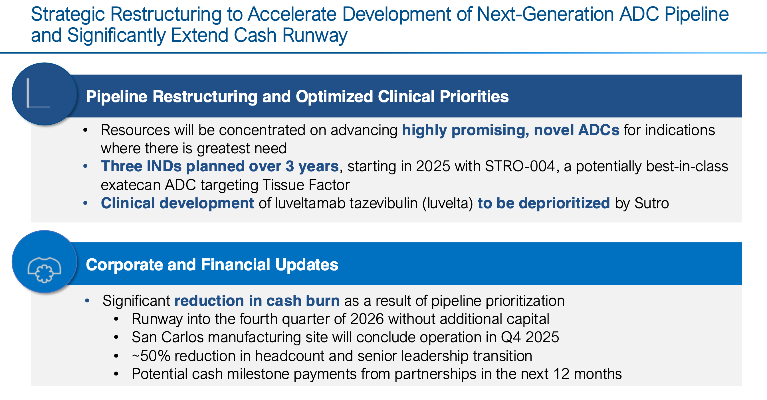
Key Q&A – summarized below, full transcript attached
- Question: When you think of the next steps for Luvelta, how much can the value be realized through partnership?
  - Answer: At Sutro, we are looking to deprioritize and wind down our additional investment in Luvelta, but at the same time, we’re in active discussions with potential partners. We want to find the right partner that could realize the full potential of Luvelta. We have some exciting data that will be shared over the weekend at SGO and I encourage everybody to go check that out.
- Question: Can you describe how the de-prioritization of Luvelta will work in terms of study enrollment? Are you pausing anything? Will you be seeking a partnership where the partner will take over clinical expenses?
  - Answer: We are looking to deprioritize and wind down our expenses as it relates to the development of Luvelta. At the same time, we are actively in partner discussions and are seeking a partner that can take over and lead the development of Luvelta in the future.
- Question: Can you talk about the key reasons for discontinuing the Luvelta program and which of those criteria you want checked as you move STRO-004 through clinical development?
  - Our decision to deprioritize Luvelta is based on capital required to take Luvelta to market, not as a result of any clinical findings. Our data for Luvelta is going to be shared at SGO and it is quite encouraging. In terms of learnings, we want to make sure we have the capital funds in place to advance STRO-004 and we want to make sure that the product profile is clearly differentiated. We recognize the ovarian space is getting more crowded.
- Question: How much should R&D and SG&A be going down this year? How long will it take to wind down operations so you can implement the savings, and how much longer could your current cash position last?
  - Our R&D expenditures in 2024 were $300M, the majority of which was for Luvelta. Without quantifying it, we do expect a dramatic decrease in overall expenditures for the remainder of 2025 and into 2026 and beyond.

For questions, please reach out to:
International / OUS Affiliates: Maureen Nail
US: Chen Gao
Corporate Strategy, R&D and PCS: Colleen Plesac

